**How to add classic Excel Print Preview to your Excel screen**

**Introduction**

Do you remember the old Print Preview screen from “classic” Excel – and how useful it was?

Well, it only takes a few clicks to get it onto your Quick Access toolbar above the Excel ribbon!

Here’s how you get it back ……..

**Methodology**

1. Gain access to the Quick Access toolbar. Select the drop down box above the Excel ribbon as per below

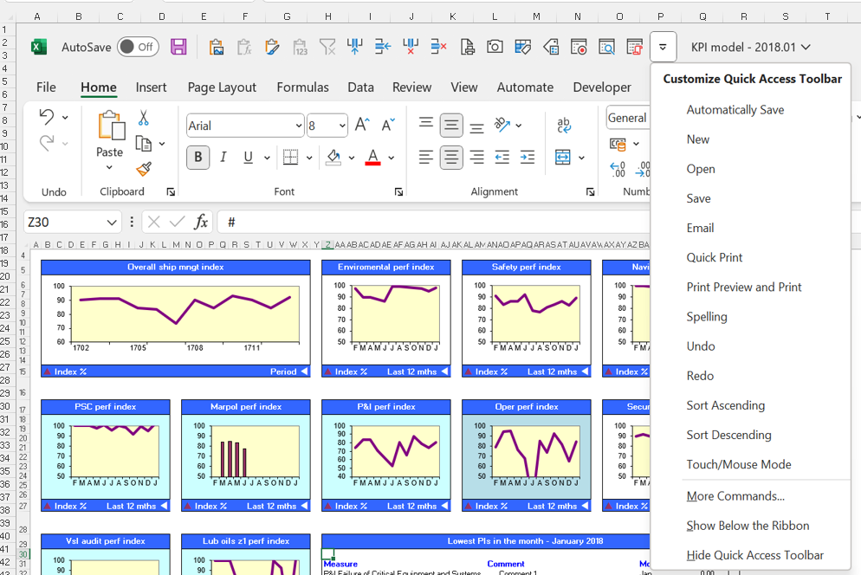

1. Select More Commands - as per the screenshot above
2. This will bring up the Excel options box ….

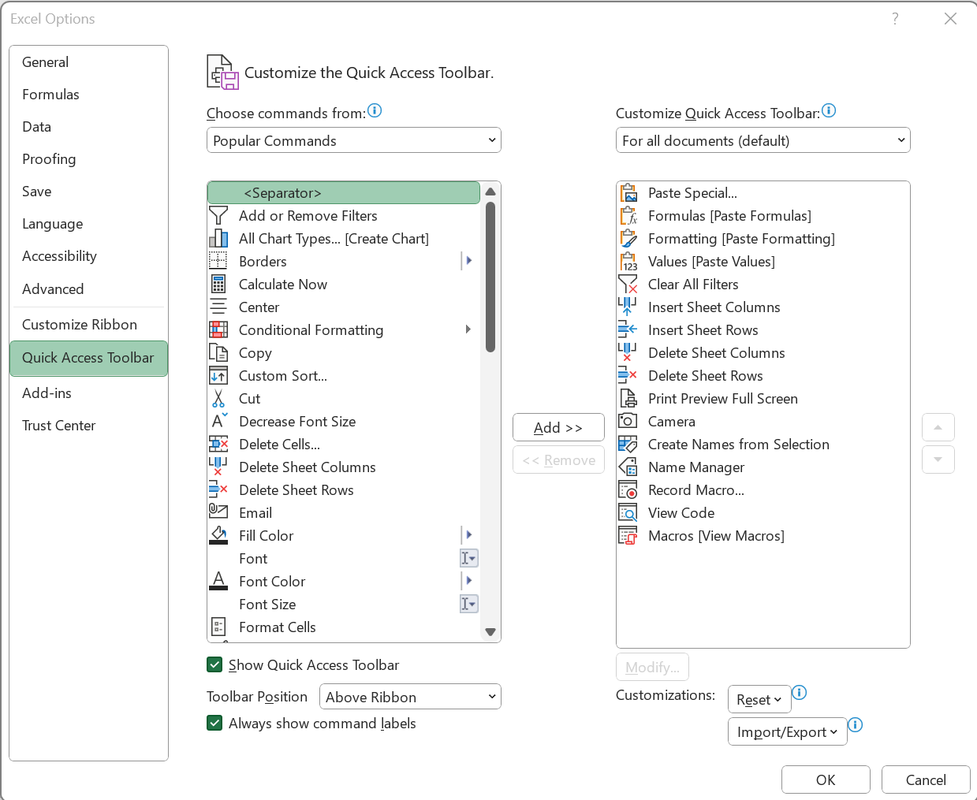

1. Click on the Choose command from drop-down box – currently set at Popular Commands

1. Select All commands. (The Print Preview icon is well hidden!)
2. Scroll down and locate the Print Preview Full Screen command (see below)
3. Select the Print Preview Full Screen command (see below)
4. Select the Add button in the middle (see below)
5. The Print Preview Full Screen command should now be in the column of commands on the right (see below)  
   As you can see, I have quite a few commands already loaded onto my Quick Access toolbar
6. Click the OK button (see below)  
     
   Hint – if you want to save your toolbar, click on the Import/Export button and Export it to a file location. Then later on you can use the Import option to load it back if you want to

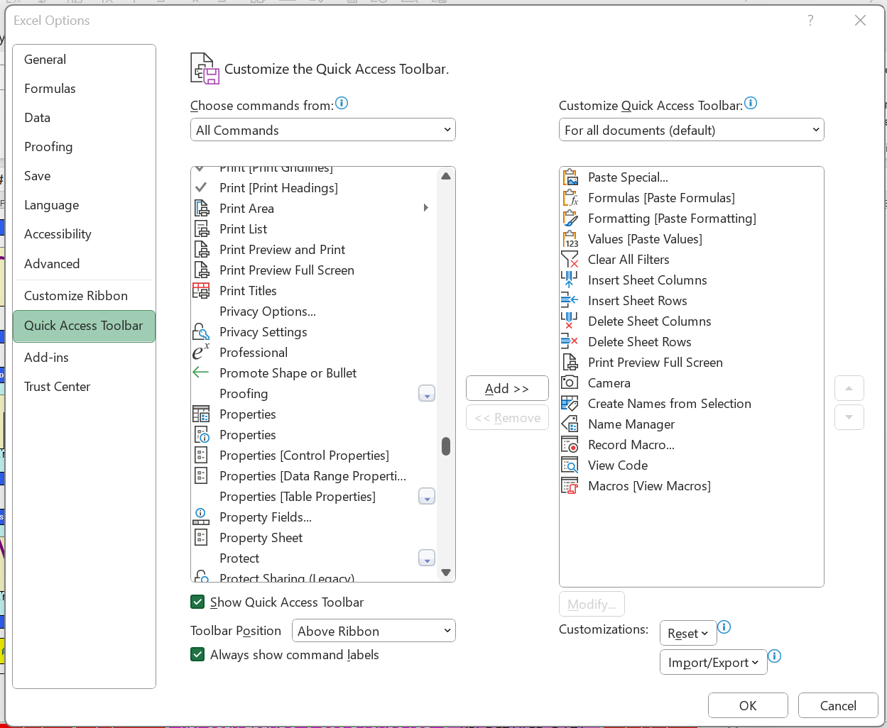

11 You should now be able to access the Print Preview icon on your Quick Access toolbar above the Excel ribbon. Just click on it and the old Print Preview screen will re-appear!



Simon Jeffery

December 2022